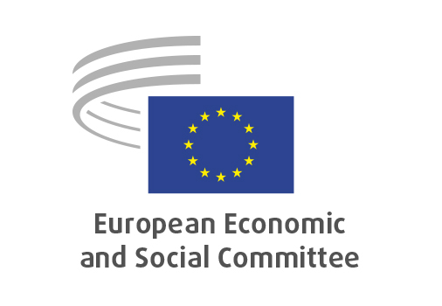
EN

INT/1088
Regulatory simplification/digital tools

Brussels, 16 July 2025

RECORD OF THE PROCEEDINGS
European Economic and Social Committee
Regulatory simplification – The use of digital tools in better law-making
[Exploratory opinion requested by the Danish Presidency]
_____________

598th plenary session
Brussels
16-17 July 2025
_____________

Meeting of 16 July
_____________

Agenda item 5
_____________

The president moved that the Committee turn to agenda item 5 – adoption of an opinion on

Regulatory simplification – The use of digital tools in better law-making
Exploratory opinion requested by the Danish Presidency.

The preliminary work had been carried out by the Section for the Single Market, Production and Consumption (president: Sandra Parthie). The rapporteur was Alena Mastantuono and the co-rapporteur was Tymoteusz Zych.

As the section had adopted its opinion with less than five votes against on 26 June 2025 and no amendments had been tabled, the Committee decided unanimously not to hold a general discussion and to put the opinion straight to the vote (Rules 64(4) and 76(3)).

The opinion was adopted by 173 votes to two, with nine abstentions.

_____________

